# Work with github

## Prerequesits

### Install git local:

Download from [Git - Install for Windows](https://git-scm.com/install/windows)

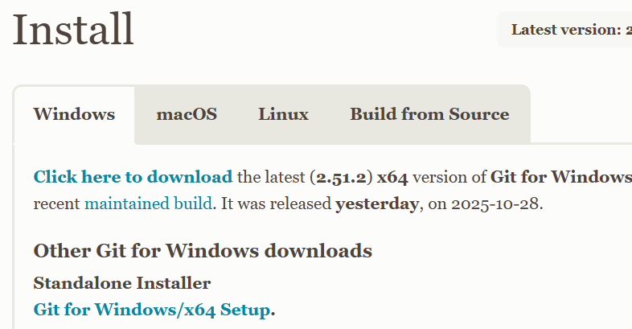

## Working with it

After installing you have git bash , start it.

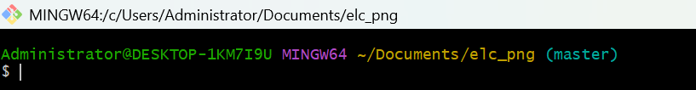

To download existing git repository: (keep in mind it’s not Windows but Linux/Unix style in man things, e.g. / instead of \)

1. Create a local directory for this e.g. /c/Users/Administrator/Documents/elc_png
2. There add the remote

git remote add origin <https://github.com/miwohlf-dot/elc-database/tree/master/deliverables>

This points to elc database

1. Git clone takes all remote files also to your local directory

## After adding or changing some code or document

The red thigs have to be written:

Administrator@DESKTOP-1KM7I9U MINGW64 ~/Documents/elc_png (master)

$ git add .



Administrator@DESKTOP-1KM7I9U MINGW64 ~/Documents/elc_png (master)

$ git commit -m "content out help for form excel to DB added"

[master 2da1c6e] content out help for form excel to DB added

27 files changed, 2 insertions(+), 13517 deletions(-)

create mode 100644 deliverables/Templates/Example to load.xlsx

create mode 100644 deliverables/Templates/~$Example to load.xlsx

delete mode 100644 deliverables/database content/congregation.csv

delete mode 100644 deliverables/database content/elc_seket.csv

delete mode 100644 deliverables/database content/tbl_admin_struc1.csv

delete mode 100644 deliverables/database content/tbl_admin_structure.csv

delete mode 100644 deliverables/database content/tbl_banking.csv

delete mode 100644 deliverables/database content/tbl_dep_pers_rel.csv

delete mode 100644 deliverables/database content/tbl_dependants.csv

delete mode 100644 deliverables/database content/tbl_elc_cong_codes.csv

delete mode 100644 deliverables/database content/tbl_elc_struc1.csv

delete mode 100644 deliverables/database content/tbl_emergency_contact.csv

delete mode 100644 deliverables/database content/tbl_pers_school_rel.csv

delete mode 100644 deliverables/database content/tbl_person.csv

delete mode 100644 deliverables/database content/tbl_residence.csv

delete mode 100644 deliverables/database content/tbl_school.csv

delete mode 100644 deliverables/database content/tbl_service_area.csv

delete mode 100644 deliverables/database content/tbl_spouse.csv

create mode 100644 deliverables/documents/mapping.xlsx

delete mode 100644 deliverables/documents/~$ample Queries.docx

create mode 100644 deliverables/documents/~$mapping.xlsx

delete mode 100644 deliverables/documents/~$rk with github.docx

delete mode 100644 deliverables/documents/~$scription of existing Database Objects.docx

delete mode 100644 deliverables/documents/~WRL0003.tmp

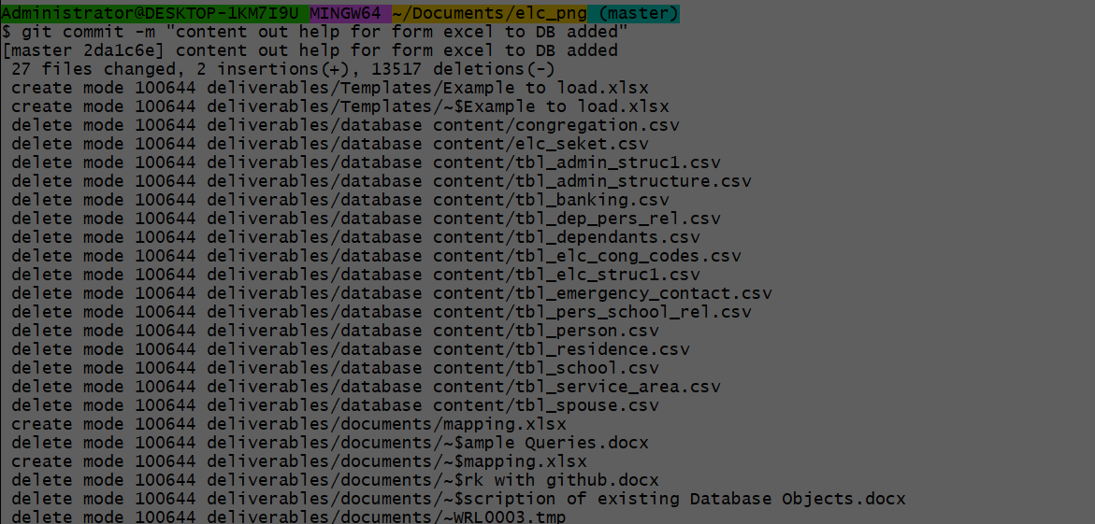

Git push to send it to remote repository

Ready